ASSIGNMENT 9
Jeremy Scheuerman

- A combinational circuit is defined with following Boolean function.
Implement it only using a multiplexer and NOT gates.
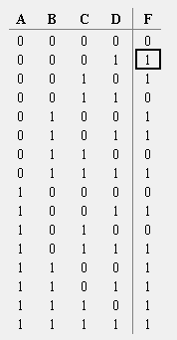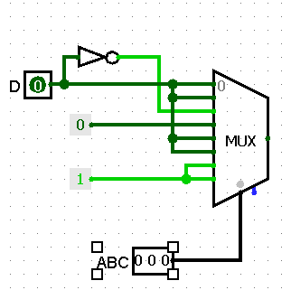

- Implement the following Boolean function with a multiplexer and an inverter with variable D as its input.
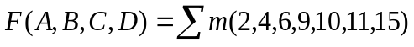
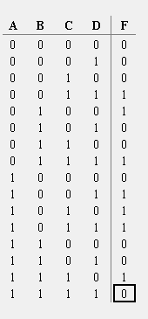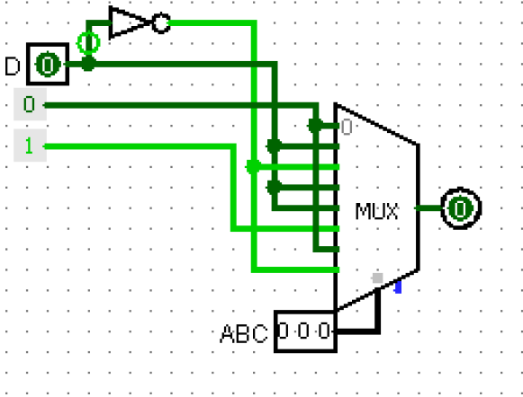

- Design an 8-to-1-line multiplexer using a 3-to-8 line decoder and eight 2 input AND gate and an 8 input OR gate.

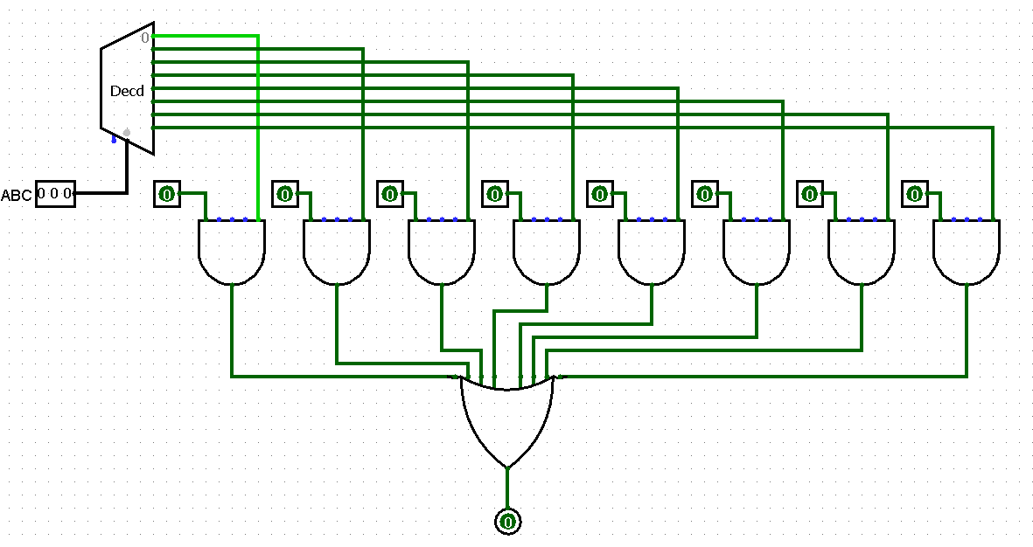
- Design an 8-to-1-line multiplexer using two 4-to-1 line multiplexer and one 2-to-one line multiplexer.
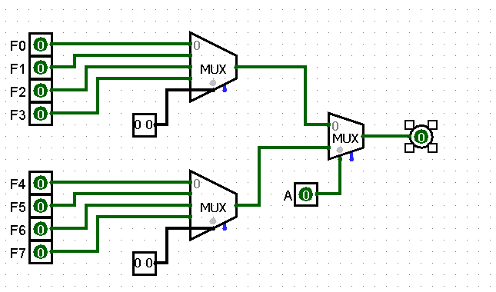

- Design multiplexer implementations for the following functions

- 
 
